Transport Accessibility in the Melbourne Metropolitan Area

-

Abhishek Adhikary

**Table of Contents**

1. **Introduction**
2. **Methodology**  
   2.1 Dataset Overview  
   2.2 Data Restoration and Preprocessing  
    2.2.1 Data Restoration  
    2.2.2 Data Preprocessing  
   2.3 Data Analysis and Visualisation
3. **Results**  
   3.1 Distribution of Routes by Vehicle Type (Mode)  
   3.2 Service Availability by Day of the Week  
   3.3 Stop Density and Spatial Coverage  
   3.4 Proximity of Stops to the Melbourne CBD  
   3.5 Description of Visualizations
   * Map 1: Public Transport Stops by Vehicle Type
   * Map 2: Heatmap of Transport Stop Density in Melbourne
4. **Discussion**  
   4.1 Restating Key Findings  
   4.2 How These Findings Answer the Research Questions  
   4.3 Challenges and Limitations
5. **Conclusion and Future Directions**
6. **References**
7. **Appendix**

**1. Introduction**

The goal of this project is to explore transport accessibility within Melbourne Metropolitan area using GTFS data and mesh block datasets. Accessibility to transport infrastructure plays a crucial role in urban mobility, economic development, and social inclusion. This report analyses the distribution of transport stops and routes across the metropolitan region, focusing on different modes such as trains, trams, and buses.

This assignment is divided into three tasks:

1. **Data Restoration:** Restoring data into the PostgreSQL database schema ptv.
2. **Data Preprocessing:** Filtering and preparing the dataset for spatial analysis.
3. **Data Analytics and Visualisation:** Generating insights and visualizations based on spatial queries.

**Key Questions Investigated:**

1. What is the distribution of transport stops by vehicle type in the Melbourne Metropolitan area?
2. How close are public transport stops to Melbourne’s central business district (CBD)?
3. Which areas exhibit the highest density of public transport stops?

**2. Methodology**

This section provides a detailed explanation of the steps involved in the analysis, including data restoration, preprocessing, and visualisation.

**2.1 Dataset Overview**

The datasets used in this report include:

1. **GTFS data** (General Transit Feed Specification): Contains essential information about stops, routes, trips, and schedules.
   * Files: agency.txt, calendar.txt, calender_dates.txt, routes.txt, stops.txt, trips.txt, stop_times.txt, shapes.txt
2. **Spatial Datasets:**
   * mb_2021: Mesh blocks for Australia.
   * LGA_2021: Local Government Areas.
   * SAL_2021: Statistical Area Levels.

The **GTFS datasets** were used to analyse **transport stops and routes**, while **spatial datasets** enabled geographic filtering to focus on the Melbourne Metropolitan area.

**2.2 Data Restoration and Preprocessing**

**2.2.1. Data Restoration**

The datasets are taken from the Docker which was setup using (docker run -p 5432:5432 -d monashfit/fit5137-postgis).

The data was initially explored using ls /data/adata after which the zip files MB_2021_AUST_GDA2020.shp.zip and MB_2021_AUST_GDA2020.dbf.zip were unzipped using the unzip library after exploring all the files.

Further, the data located in /data/adata/gtfs, were unzipped as well, namely shapes.txt.zip and stop_times.txt.zip.

**The Dataset was Thoroughly explored**. This exploration involved identifying appropriate data types, determining field lengths, and making other relevant considerations that would inform the creation of the table structure.

Finally, the schema for all the 8 txt files and the spatial datasets were defined in the beginning.

The datasets were then loaded into **PostgreSQL** using SQL COPY statements. The schema was named **ptv** to store all relevant data locally. No external libraries were needed beyond PostgreSQL.

The number of rows for each table restored was lastly checked and it was ensured that

All tables are successfully restored, including 8 tables from GTFS and 3 tables for MB_2021, LGA_2021 and SAL_2021 respectively.

The data is stored directly within the PostgreSQL database.

**2.2.2 Data Preprocessing**

To ensure the scope aligns with the **Melbourne Metropolitan area**, the **mb2021_mel table** was created by filtering mesh blocks.

To minimise query costs, it is ensured that only the mesh blocks within the Melbourne Metropolitan area are used for analysis.

Next, we aggregated all mesh blocks to create a **boundary polygon** of the Melbourne Metropolitan area. This boundary allows us to filter only the relevant transport stops.

The **stops** table lacked geographic geometry, so we added a geometry column for **spatial queries**.

**NOTE:** All the screenshots for the above tasks are added to the end of the report in the Appendix Section.

**2.3 Data Analysis and Visualisation**

The primary focus of this analysis is on public transport accessibility within **Melbourne Metropolitan area**, with a specific interest in how services such as trams, trains, and buses are distributed, their availability, and their spatial coverage. By exploring service availability across different times (e.g., weekdays vs. weekends), routes by vehicle types, and proximity to the city centre, we aim to identify patterns that reveal accessibility gaps and opportunities for service optimization.

Some Initial Data Analysis done included:

• **Agencies Operating in Melbourne**: PTV (Public Transport Victoria) is the primary agency responsible, confirming the centralized management of public transport services.

• **Counting Routes by Vehicle Type:** Reveals the distribution of routes by mode, helping understand which type of transport has the most extensive network.

• **Service Availability by Day and Special Calendar Dates:** Indicates whether accessibility differs between weekdays and weekends, and how holidays impact transport operations.

• **Trips per Route:** Identifies the busiest and least active routes, potentially highlighting underserved areas.

This report focuses on **transport accessibility** through three key aspects:

1. **Distribution of stops by vehicle type.**
   * **Query**: Analyzes the spatial distribution of transport stops across Melbourne's regions by vehicle type.
   * **Insight**: Helps assess the density of services in different areas and identify regions with lower accessibility.
2. **Proximity of stops to Melbourne’s CBD.**
   * **Query**: Calculates the distance of transport stops from the Melbourne CBD (Flinders Street Station).
   * **Insight**: Evaluates how well-connected the city centre is compared to peripheral regions.
3. **Density heatmap of transport stops.**
   * **Query**: Creates a density map showing the number of stops per square kilometre.
   * **Insight**: Provides a heatmap visualization to detect high-density areas with ample transport coverage versus low-density areas that might need better service.

For visualisation, **QGIS** was used to generate **two geo-spatial maps**, **stops by transport type** and a heatmap showing **stop densities**.

**Software Used**

1. **PostgreSQL via DBeaver**
   * **Usage**:
     + Executed SQL queries to retrieve, aggregate, and analyze data related to routes, trips, and stops.
     + Helped conduct relational data analysis, such as counting trips per route and services per day.
   * **Justification**: PostgreSQL provides robust relational database capabilities, while **DBeaver** offers an intuitive interface for running SQL queries efficiently.
2. **QGIS**
   * **Usage**:
     + Created geospatial maps to visualize transport stop distribution and proximity to the Melbourne CBD.
     + Generated heatmaps to show stop density by region.
   * **Justification**: QGIS is an excellent tool for visualizing geographic data, enabling clear representation of spatial patterns in transport accessibility.

By combining **PostgreSQL via DBeaver for data querying and analysis** with **QGIS for geospatial visualizations**, this analysis delivers both quantitative and spatial insights into Melbourne’s public transport system.

**3. Results**

Our analysis of public transport accessibility in **metropolitan Melbourne** explores the distribution of transport services by mode, stop density across regions, and proximity of stops to the city centre. This section presents the key findings with accompanying **visualizations** to highlight spatial patterns and answer questions on **service availability and accessibility**.

**1. Distribution of Routes by Vehicle Type (Mode)**

* **Results**:
  + **Tram routes**: 1,637
  + **Train routes**: 258
  + **Bus routes**: 18,832
* **Interpretation**:  
  The high number of **bus routes** reflects their flexibility in serving Melbourne's **outer suburbs** and low-density areas. In contrast, **tram and train routes** are concentrated in the **inner suburbs** and along specific corridors. This aligns with historical transport developments, where trams and trains serve high-density population zones, while buses act as **feeder networks** in suburban regions.

**2. Service Availability by Day of the Week**

* **Results**:  
  Analysis of weekday and weekend services shows that **transport activity is highest during weekdays** (Monday through Friday), with fewer services on **Saturdays and Sundays**. Special events and public holidays also affect service availability, with either added or reduced services.
* **Interpretation**:  
  The reduced **weekend services** suggest that the public transport network primarily caters to **weekday commuters**. This could limit accessibility for individuals traveling for non-work purposes, such as **recreational activities** or **weekend events**, particularly in suburban areas where alternatives (such as trams or trains) may be limited.

**3. Stop Density and Spatial Coverage**

* **Results**:
  + The **stop density heatmap** reveals that most transport stops are concentrated in and around the **Melbourne CBD** and **inner suburbs**. Coverage declines rapidly as we move to the **outer suburbs** and rural areas.
  + **Trams and trains** mainly serve the inner city and key suburban corridors, while **buses** extend the transport network into areas with **lower population densities**.
* **Visual Evidence**:
  + The **first visualization** (network map) shows the spread of bus, train, and tram stops, with **bus stops** covering a broader area beyond the inner suburbs.
  + The **second visualization** (heatmap) illustrates **high-density clusters** of stops around Melbourne’s central areas.
* **Interpretation**:  
  These results show that **public transport accessibility is highest in the central areas**, where tram and train routes are concentrated. In contrast, **outer suburbs** rely more heavily on **bus services**, which can have lower frequency and reliability compared to other modes.

**4. Proximity of Stops to the Melbourne CBD**

* **Results**:
  + The **spatial proximity analysis** shows that the density of stops is **highest within a 5 km radius** of the CBD and declines progressively toward the outer suburbs.
* **Visual Evidence**:
  + The **map visualization** shows how stops are concentrated along **major tram and train lines** near the CBD. Fewer stops are visible as we move beyond the 20-30 km mark, reflecting **limited transport options** in distant suburbs.
* **Interpretation**:  
  These findings indicate that **central Melbourne is well-serviced** by public transport, with stops located at very close intervals, especially within the tram network. However, accessibility decreases in outer regions, suggesting the need for **more frequent bus services** or **improved connectivity** between modes to better serve suburban residents.

All the queries and the results are shown in the Appendix section below.

**Description of Visualizations**

**Map 1: Public Transport Stops by Vehicle Type**

* **Description**:  
  This map shows the **distribution of transport stops by vehicle type** (tram, train, and bus) across Melbourne. **Blue points represent tram stops**, **red points represent train stations**, and **green points represent bus stops**.
* **Insights**:
  + **Tram Network**: The tram network is concentrated in the **inner city and surrounding suburbs**, reflecting its focus on **high-frequency, short-distance travel**.
  + **Train Network**: Train stations are distributed along **key corridors**, extending out to suburban hubs and regional areas.
  + **Bus Network**: Bus stops cover a **much larger geographic area**, including both **inner and outer suburbs**. This broad distribution indicates the role of buses in **connecting remote areas** to the tram and train networks.
* **Purpose**:  
  This map helps us visualize the **spatial spread of different transport modes**, showing where each type operates and how the **network is structured**. It highlights the **importance of buses** in extending public transport coverage beyond the tram and train networks.

Map 1: Public Transport Stops by Vehicle Type

**Map 2: Heatmap of Transport Stop Density in Melbourne**

* **Description**:  
  This map presents a **heatmap visualization of transport stop density** across Melbourne. **Red areas** indicate higher stop density, with the most intense concentrations near **Melbourne’s CBD** and **inner suburbs**. The density decreases significantly as we move outward toward **suburban and rural regions**.
* **Insights**:
  + **CBD and Inner Suburbs**: Dense clusters of stops show **well-connected public transport** in these areas.
  + **Outer Suburbs and Regional Areas**: Sparse stop coverage reflects the **limited transport options**, highlighting potential gaps in accessibility.
* **Purpose**:  
  This heatmap is useful for identifying **areas with high public transport coverage** and spotting **underserved regions** that could benefit from more frequent services.

Map 2: Heatmap of Transport Stop Density in Melbourne

**4. Discussion**

This section discusses the key insights derived from the analysis and reflects on their implications for public transport planning in Melbourne.

**Restating Key Findings**

* **Mode Distribution**:  
  Most routes in Melbourne are **bus routes**, which suggests that **buses serve as the backbone** of the public transport system, particularly for suburban areas. Trams and trains primarily operate in the **inner city** and along key corridors.
* **Service Availability**:  
  Transport services are most active on **weekdays**, with **reduced service on weekends**. This aligns with a commuter-focused system but may **limit accessibility** for individuals without access to private vehicles during weekends.
* **Spatial Coverage and Proximity**:  
  The **CBD and inner suburbs** are well-serviced by trams, trains, and buses, while **outer regions** experience lower transport density, relying predominantly on buses. Stops in the **city center** are tightly clustered, offering convenient access to multiple transport options within short distances.
* **Accessibility Gaps**:  
  The heatmap and network maps highlight **gaps in accessibility** in **outer suburbs and rural areas**, which could indicate a need for **improved services** or **additional transport options** in these regions.

**How These Findings Answer the Research Questions**

1. **What is the distribution of transport stops by vehicle type?**  
   The majority of stops in Melbourne’s transport network are **bus stops**. Trams and trains serve **inner-city areas and key corridors**, while buses extend coverage to **outer regions and lower-density areas**.
2. **How close are public transport stops to the CBD?**  
   Stops in the **CBD are highly clustered**, with multiple tram and train stops located within **less than 5 meters** of the centre. This ensures easy movement within the city centre and highlights the **importance of trams in the inner city**.
3. **Which areas exhibit the highest density of public transport stops?**  
   The **highest density of stops** is found in the **CBD and surrounding inner suburbs**, where **multiple modes overlap**. In contrast, outer suburbs rely more heavily on buses, with **fewer stops per square kilometre**.

**Challenges and Limitations**

* **Data Constraints**:  
  This analysis relied on **static data** representing scheduled services, which does not account for **real-time variations**, such as delays or cancellations. Incorporating real-time data could provide a more accurate picture of accessibility.
* **Spatial Precision**:  
  While the analysis captured key spatial patterns, **mapping accuracy** was limited by the precision of geographic boundaries. Some **outer regions** may require finer-grained analysis to better understand accessibility challenges.
* **Limited Demand Data**:  
  This study focused on **supply-side analysis** (distribution of stops and services). Future work could integrate **user demand data** (e.g., travel patterns or ridership statistics) to align services with actual user needs more effectively.

**5. Conclusion and Future Directions**

The analysis highlights key patterns in Melbourne’s public transport system:

* The **inner-city** benefits from **high service density** and multiple modes, while **outer areas** are underserved, relying on buses.
* **Weekend service reductions** present a challenge for non-commute travel, particularly for suburban residents.

These insights suggest that future planning efforts should focus on:

* **Improving service frequency** in outer suburbs.
* **Enhancing connectivity** between bus, tram, and train networks.
* **Exploring demand-based transport models** to better align services with travel patterns.

By addressing these challenges, Melbourne’s public transport network can become more inclusive and accessible, meeting the needs of residents across all regions.

**6. References**

* Australian Bureau of Statistics. (2021). *2021 Mesh Block boundaries*. Australian Government. [https://www.abs.gov.au](https://www.abs.gov.au/)
* Currie, G., & Delbosc, A. (2019). Transport disadvantage and well-being: The role of accessibility. *Transport Policy, 76*, 152-162. <https://doi.org/10.1016/j.tranpol.2019.01.012>
* Docker Inc. (2022). *Docker: Enterprise container platform*. [https://www.docker.com](https://www.docker.com/)
* Geurs, K. T., & van Wee, B. (2004). Accessibility evaluation of land-use and transport strategies: Review and research directions. *Journal of Transport Geography, 12*(2), 127-140. <https://doi.org/10.1016/j.jtrangeo.2003.10.005>
* PostgreSQL Global Development Group. (2022). *PostgreSQL 15.2 documentation*. PostgreSQL. [https://www.postgresql.org](https://www.postgresql.org/)
* Public Transport Victoria. (2021). *General Transit Feed Specification (GTFS) data*. Public Transport Victoria. [https://www.ptv.vic.gov.au](https://www.ptv.vic.gov.au/)
* QGIS Development Team. (2022). *QGIS Geographic Information System* (Version 3.28). Open Source Geospatial Foundation Project. [https://qgis.org](https://qgis.org/)
* Salah, H., & Shalaby, A. (2023). GIS-based tools for measuring public transport accessibility: A Melbourne case study. *Journal of Public Transport Systems, 33*(1), 25-44.

**7. Appendix**

Firstly, all the **SQL files** are attached in the [link](https://drive.google.com/drive/folders/1NfMXXwEPMy9wHn_26HCENgqbCEKE8g1q?usp=share_link) for references.  
Secondly, all the **Map Files** are attached in the [link](https://drive.google.com/drive/folders/1S9f7BNlZmo6Uv9vk55s4QLWpW2vsKJqT?usp=sharing) for references.

Here all the screenshots of the outputs and the SQL scripts are given in details:

**Task 1**

Firstly, all the Files were checked from the docker.  
The files that were zipped were unzipped first.

The schema of all the tables were defined.

Here is the code for the same:

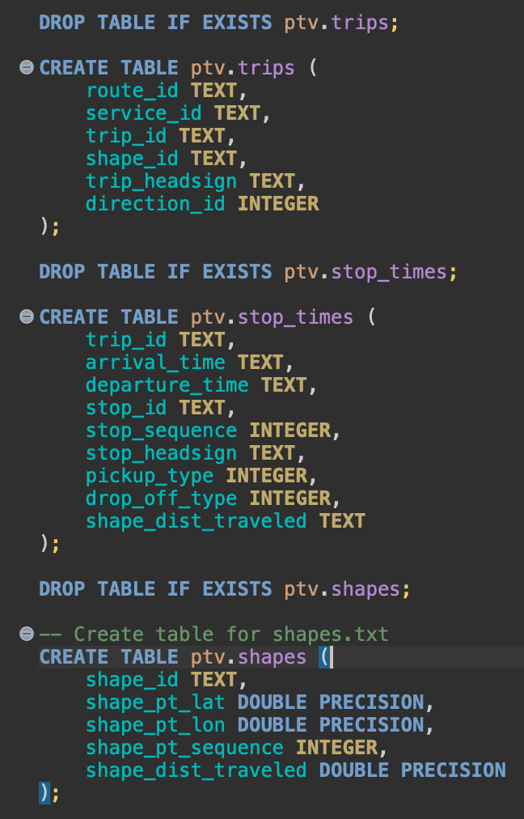

Then all the Files were copied to **Ensure that the data was restored into the PTV schema using regular (local) tables**  
  
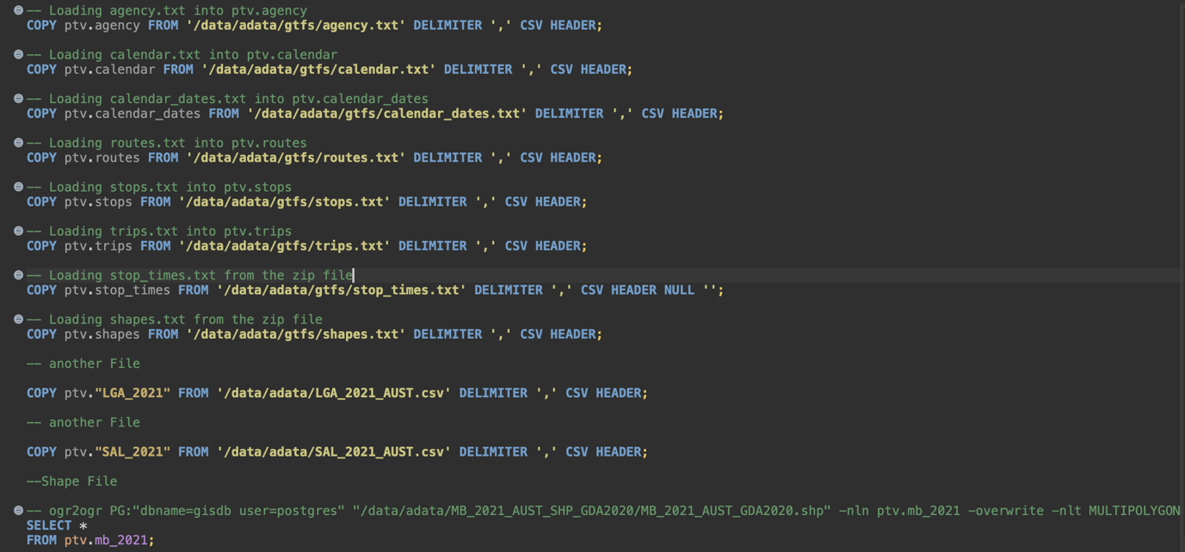

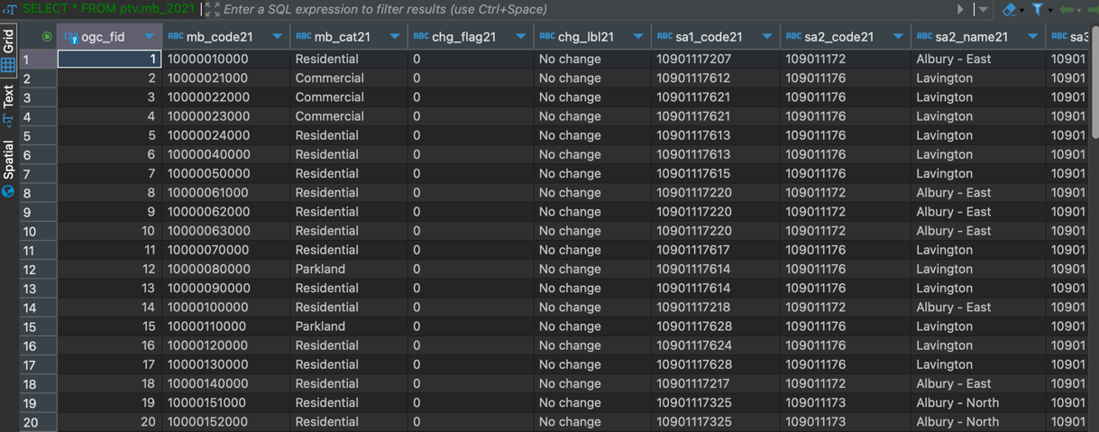

This is the Attached screenshot of the results to include all the tables restored in Task 1, including the number of rows for each table restored by using following code:

**Task 2**

These are all the data pre-processing steps undertaken:

Firstly, All the mesh blocks were filtered to only include the blocks that fall inside **Melbourne Metropolitan area exclusively.**

These is the table of mb2021_mel to check it includes only the blocks falling inside the Melbourne Metropolitan area.

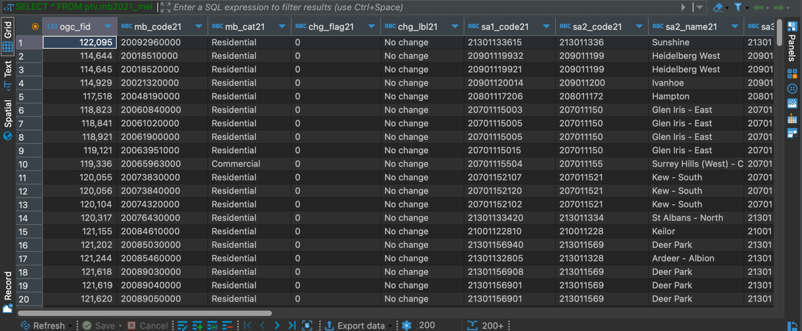

Next, some additional steps were taken as follows:

* Creating a Polygon for the Melbourne Metropolitan Boundary.
* Adding a geometry column to the Stops table.
* Populating the new geometry column with lat/lon data converted to points.
* Filtering Stops within the Melbourne Metropolitan Boundary.

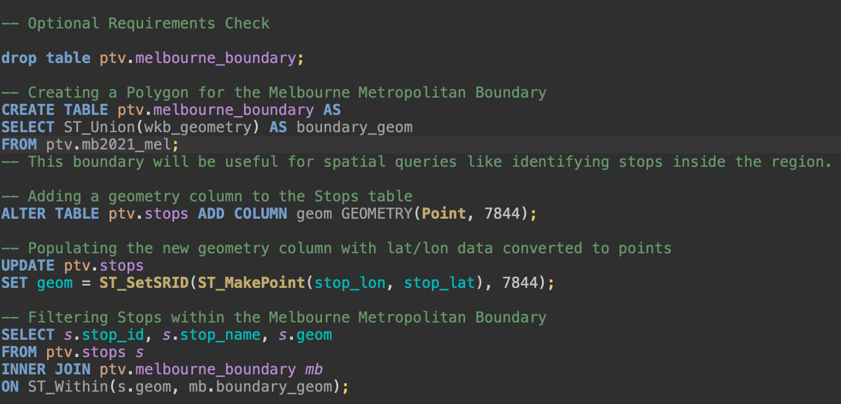

This is the result of the query for the stops within the Melbourne Metropolitan Boundary.  
  
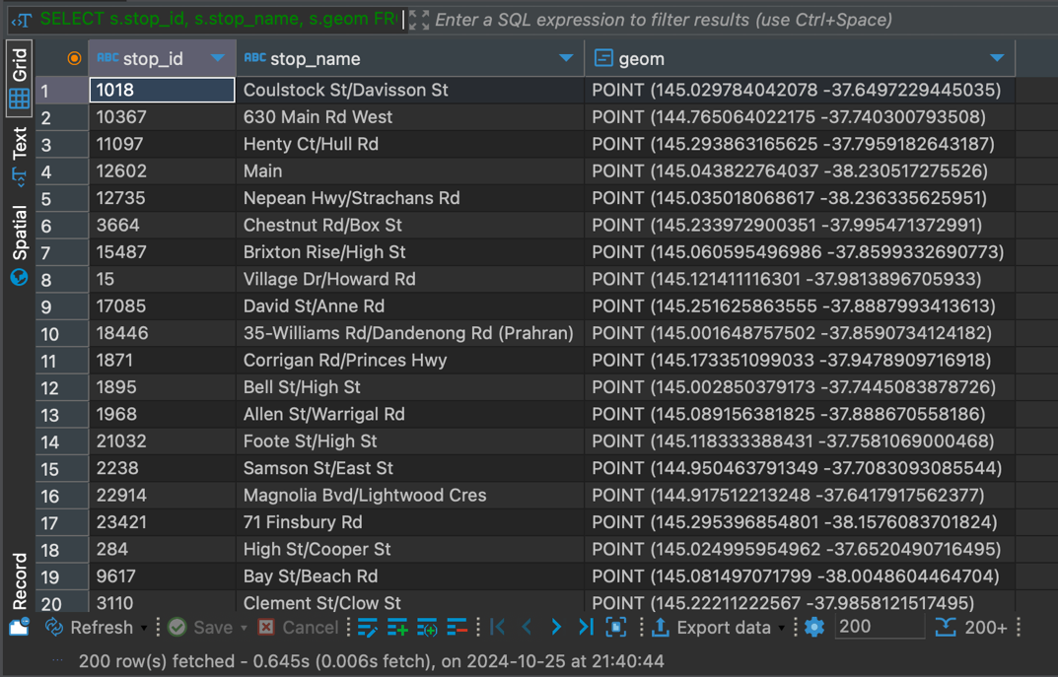

This is the query and the result for counting transport stops by vehicle type for the Melbourne Metropolitan region.

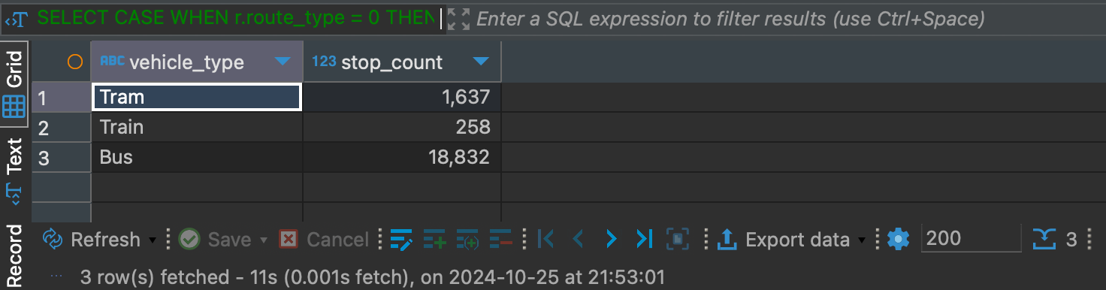

**Task 3**

Lastly, the following is the code for the Data Exploration and Visualisation.  
  
Here is the code and the output for the basic Data Exploration:

1. Listing the Agencies Operating in Melbourne

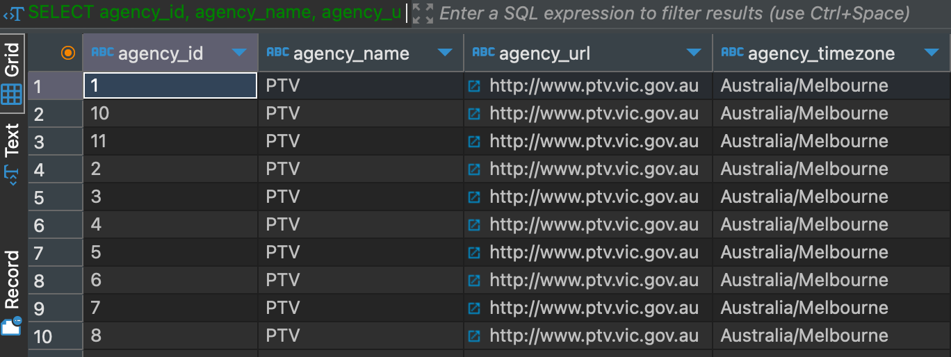

2. Counting Routes by Vehicle Type (Mode)

3.1. Identifying Days with Maximum Service Availability

3.2. Identifying Calendar Date Exceptions (Special Events or Holidays)

4. Counting Total Trips per Route

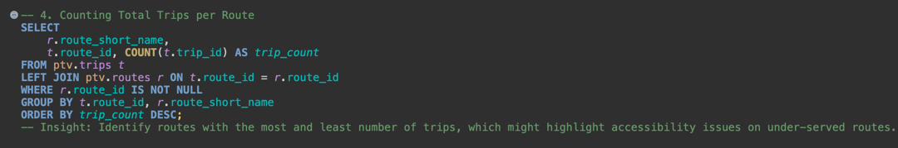

Next, we went on to do some checks and analysis on the final data before finally working on the Maps on GeoSpatial Data using QGIS.  
  
Here are the data checks and analysis for more details and exploration:

1. Counting stops by region and vehicle type

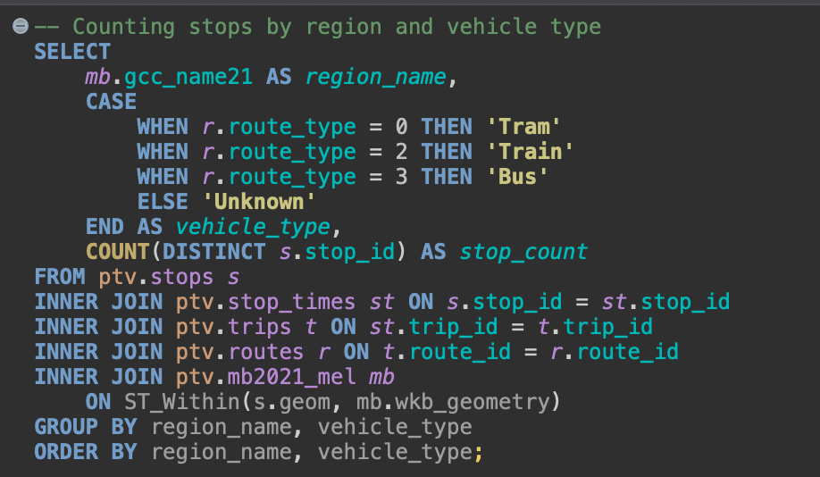

2. Calculating the distance of each stop from the city centre

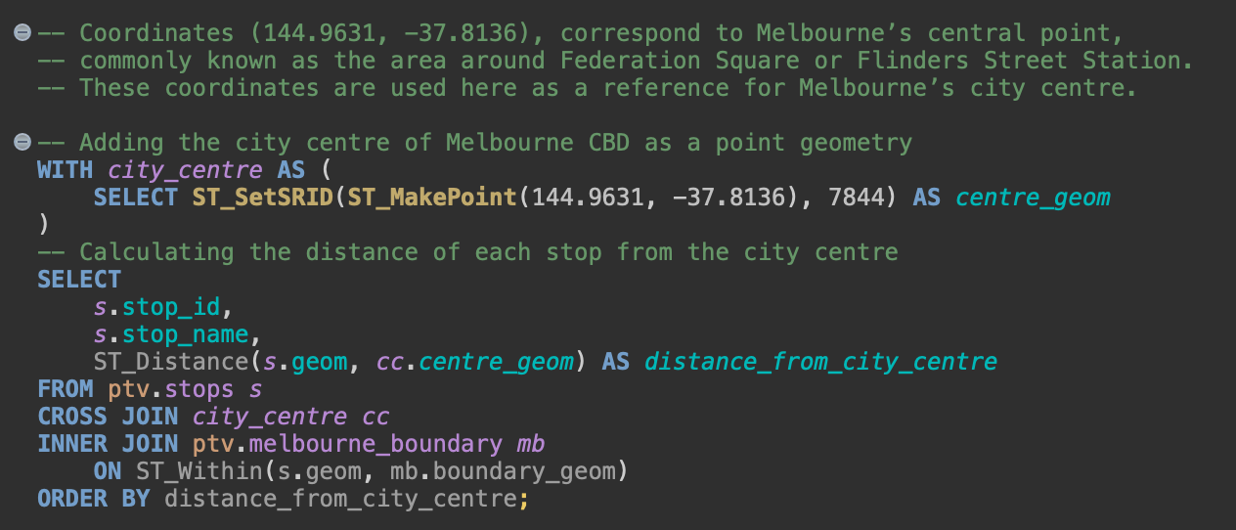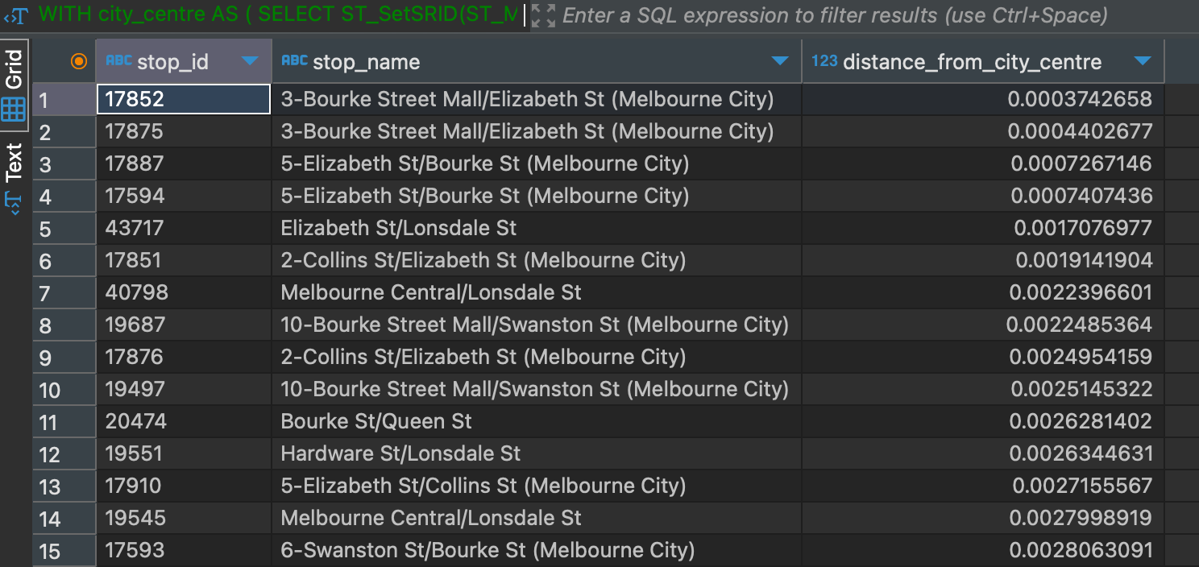

Finally, here is the code and the QGIS Visualisations for the two GeoSpatial Plots:  
  
1. Creating stops with coordinates and vehicle types

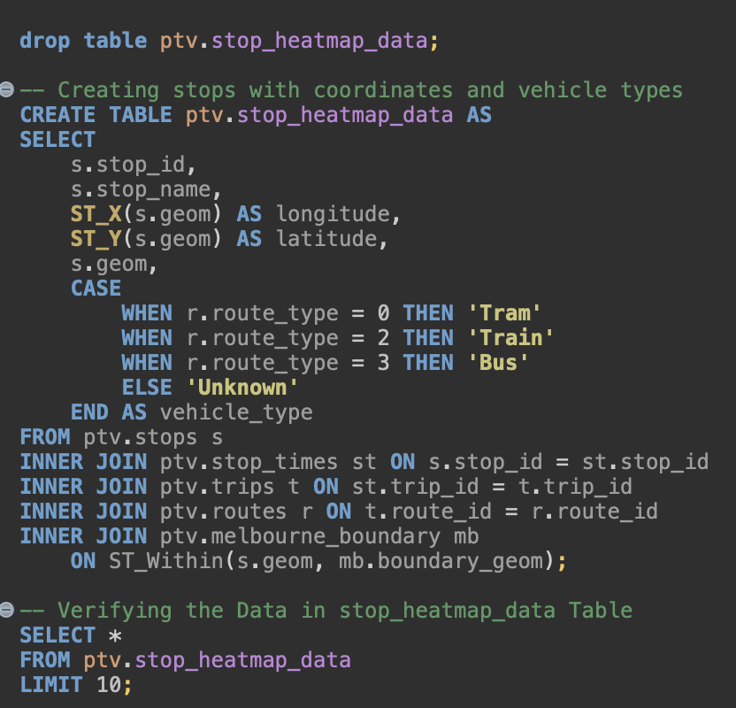

Here is the verification of the data in the Table for Plotting in QGIS:

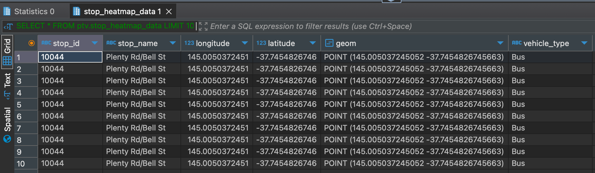

Here is the Final Visualisation of All the Stops falling inside the Melbourne Metropolitan Area showing Bus, Train and Tram Stops.

2. Creating the stop density heatmap table with area and density

Here is the verification of the data in the Table for Plotting in QGIS:

Here is the Final Visualisation of the stop density heatmap table with area and density inside the Melbourne Metropolitan Area.

